XCom

Alliance

Episode A3
Ordeal of fire

(Map: The sector command post)

Originally Map x: (originally created by R. Letham)
Contents

MAPS
Map Level 1
Map Level 2
Map Level 3
Map Level 4
Map Level 5
Map Level 6
Intro to Level
What has gone before
Player Mission briefing:
Structure of level
Overview
A story (plot)
B story (subplot)
Game Aim
Game function
Level B2 Walk through:
Act 1
Act 2
Act 3
Debriefing
Additions / Changes in more detail
Equipment for level
Changes to Geometry/layout
Extra objects
Gore
Recommended Programming Additions
Level B2 Art requirements
Level B2 Sound Requirements
Level B2 Environmental Analysis

MAPS

Map Level 1

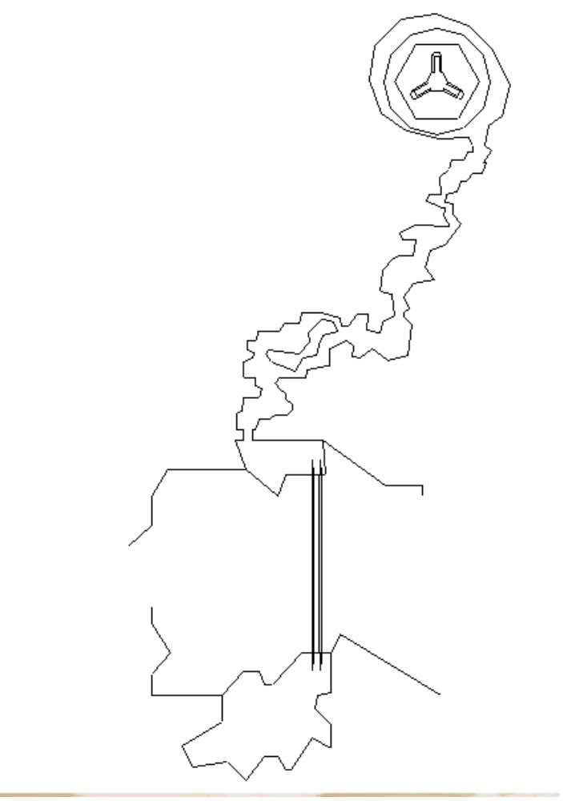
Legend:
Sectoid.Unarmed
Plasma
Neuraliser
Commander
Guard
02
03
04
05
06
07
08
09
10
11
12A
12B
12C
13B
13A
13C
13
01

Map Level 2
Lift to
Map level 3

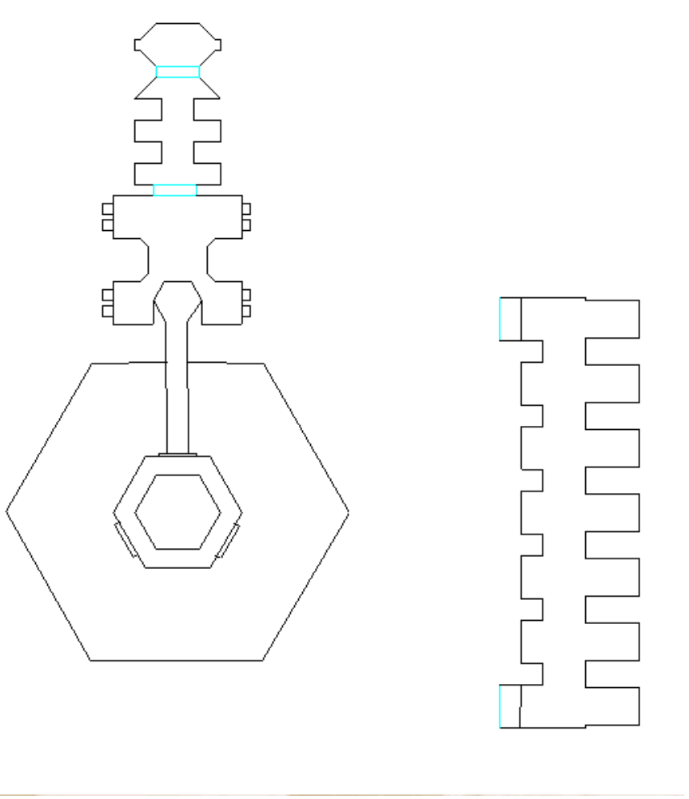
14A
14B
14C
15A
15B
24A
24B
24C
24D
24E
24F
24G
17
16
24

Map Level 3

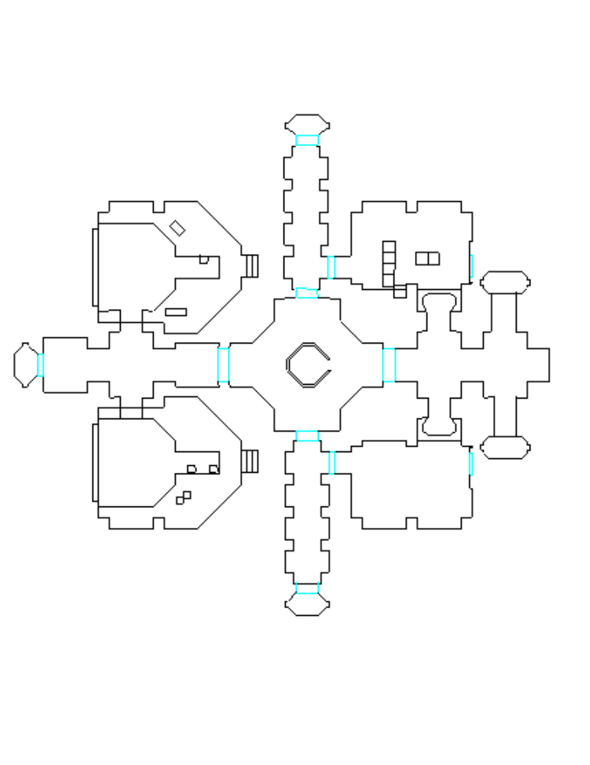
22A
22
22b
Lift to Maplevel 2
Lift to Maplevel 5
Lift to Maplevel 4
Lift to Maplevel 4
19
20A
20B
20CA
Slope to Maplevel 2
Slope to Maplevel 2
20
20DA
21
23AA
23
23BA
23CA
Lift to Maplevel 4
25
26E
26A
26B
26C
26D
27
28A
28B
29A
29B

Map Level 4
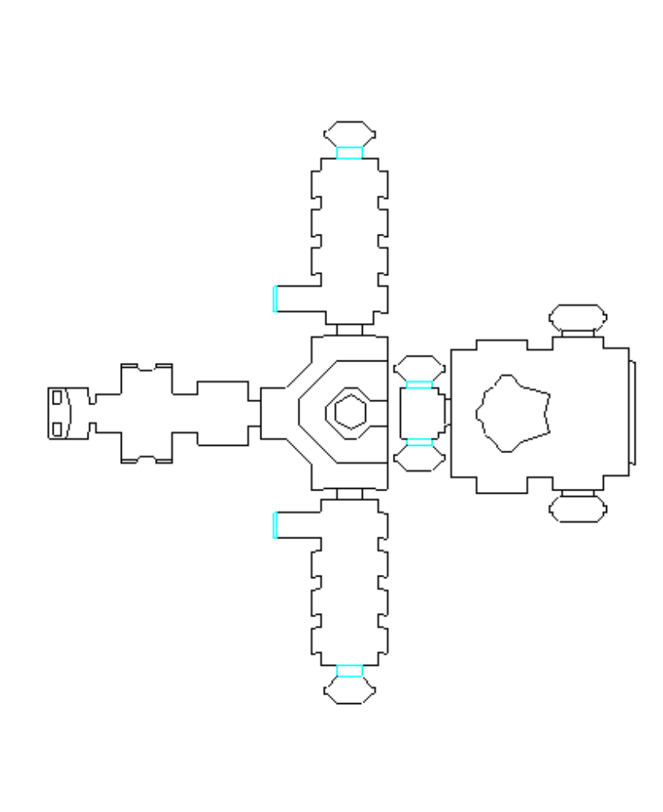
31B
Lift to Maplevel 5
25
Lift to Maplevel 3
32
33
Lift to Maplevel 5
Connects to 29B
(Map Level 3)
Connects to 28B
(Map Level 3)
Lift to Maplevel 3
26F
26G
26H
33C
33B
31
31C

Map Level 5

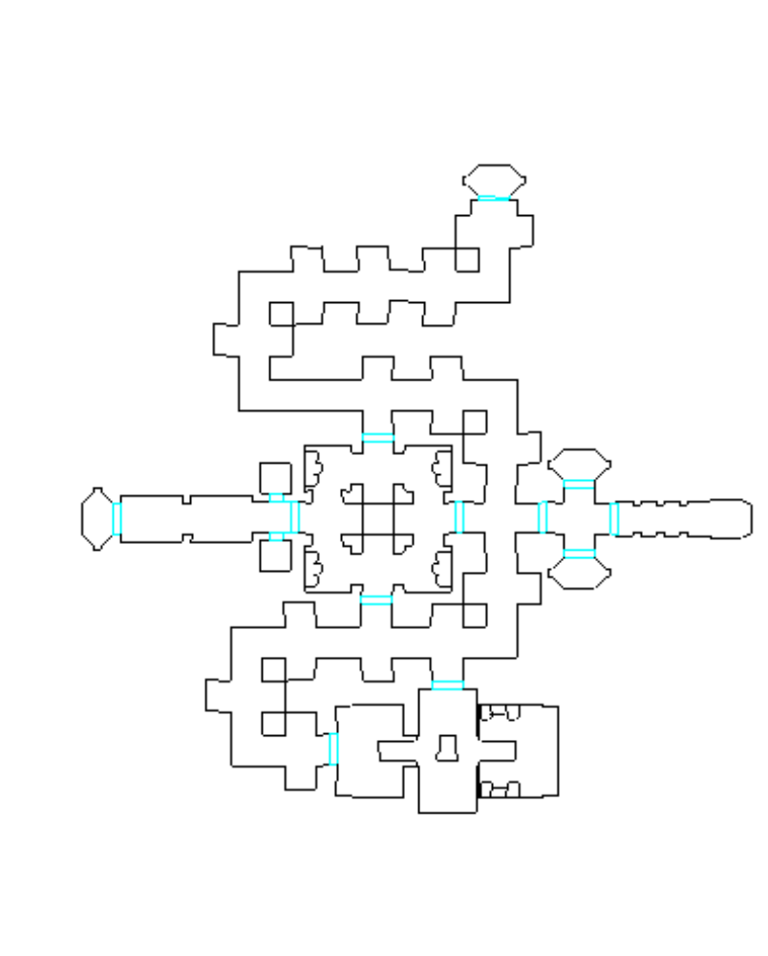
Lift to Maplevel 4
Lift to Maplevel 6
Lift to Maplevel 4
Lift to Maplevel 3
34
40A
36
37
38
39
40
41
42
43
44
40B
40C
40D
40E
40F
45A
46A
41A
41B
45B
46B
42B
47B
47A
35B
35A

Map Level 6

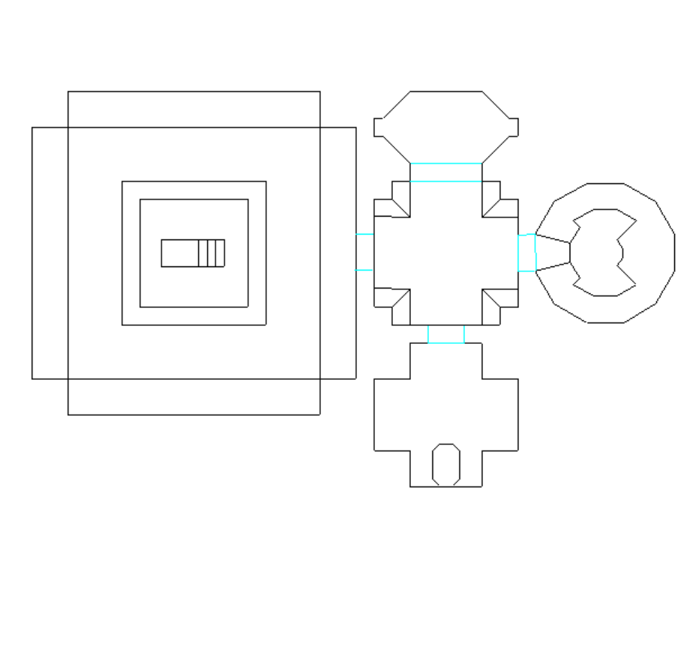
Lift to Maplevel 6
51A
51
48
50
49

Intro to Level

TBD

What has gone before

Player Mission briefing:

Change to end cut scene

There is some debate on how difficult and time consuming the cut scenes will be to finish off.

Originally the player was to ‘capture’ and recover a prisoner and take him back for the Ascidians to extract information.

Carrying this out in game with the existing commands and control structure is difficult at best.

Hence in the current plot now has the Sectoid ‘commander’ being killed, and his biochip taken back to the Ascidians. (This plot device is also used elsewhere in the game).

Doing this has a couple of effects:

- It will negate the need to have the interrogation cut scene, and Mathew’s sequence alone should suffice.
- We don’t have to worry about actually ‘capturing’ the commander.

If later, the cutscenes do not pose a problem, then the scene can be re-added with appropriate changes.

(E.g the following sequence, or something similar could happen instead)
- In a darkened room an Ascidian is handed the biochip by a human (Captain or Yaeger).
- The Ascidian croaks a ‘thank you’.
- As the human turns to leave, they ask “What use is it?”
- A light in a darkened room will come on revealing a Sectoid strung up, the camera tracks in.
- The Ascidian will move forwards towards the camera( and towards the Sectoid) holding up the chip, and extending a long knife. The human should be visible in the background.
- The Ascidian will croak ‘I reveal now its use.’ And pass out of camera, the focus will be on the human.
- From off screen come squelching sound effects and a Sectoid screams, the human pales and looks sick.

Structure of level

Overview

A story (plot)
Forge an alliance with the Ascidians.

B story (subplot)
The captains initial distaste of the ‘assassination’ approach.

Game Aim
- Find the commander and extract his bio-memory chip
- Disable any equipment found.

Game function
Give the player experience of 4 troopers.
Introduce the player to timed events, and the advantages of stealth.

Number of troopers
4
This should be the first mission with a full complement of troops (whatever that turns out to be)

Setting off of alarms
Stealthy play will be rewarded. (This also includes leaving no survivors to raise alarms.)

In each group of aliens spotted it will be the function of one of these to raise the alarm.

This should be done either:

- Breaking off from the main group and legging it for a console (the alarm can then be assumed to be raised).
Setting off an alarm should take 5 seconds# (once the Sectoid has reached a console)

- Standing fiddling with his neuraliser whilst the others attack (the alarm is assumed to be raised by this device).
Setting off the alarm in this way should take 20 seconds#.

# These times should be tuned by playtesting and could be way out.
Aliens within the ship will mainly use the former, while those in the caverns will use the second option.

Ideally aliens coming across dead aliens, or gibbed bits, should also trigger them to raise the alarm.(Unfortunately we lack the ability to have troopers move bodies or we could make a lot more with this)

Once the alarm is raised the resistance should increase.

Within this doc I will refer to this as spawning extra aliens if the alarm has gone out.
(It could however equally well be reversed, and these same aliens flagged for destruction if the alarm hasn't gone off.

Always bear in mind the 'idea' of what is wanted here.
If you can suggest a better way of getting the same effect please do.

Level creatures
- Sectoids
- Normal Drones
- 'Commander'
- High Mentat (First appearance)

- Guards (First appearance)

Set piece Dramatics

Eclipse
Skyzone needs to be set up properly.
The eclipse needs to be properly choreographed.

The Saucer 'vents'
The vents are possibly the most complicated thing that needs to be set up.

Time limits

The level is played out against the backdrop of the impending Ascidian attack.
*These times should be used as a difficulty setting for the level.

Patton Messages

Recommended Crew members

TBD

Level B2 Walk through:

NB Rooms are not strictly in numerical order, they are in the order they are likely to be met in the mission.

Act 1
Room 1 Setup
- New ‘canyon added, with old battered Ascidian landing pad.
- Carved ‘Ascidian Frame’ around cave/tunnel leading to ‘room2’
Room 2
- The box surrounding the canyon needs to be simplified and reduced (now we can do the whole thing a lot better with the skybox).
- It might also be a good idea to remove some of the furthest canyon geometry.

Room 3
- Add Ascidian 'frame' over the cave entrance

Room 4
- Add Ascidian 'Alter'

Room 5
- Two Sectoids (forming a group) One with neuraliser one with plasma
- If surprised one should try and set the alarm.
- If the player bypasses these completely, and gets as far as the room 7/8 bottleneck, then these two Sectoids should be activated anyway.

Room 6
- Add Ascidian 'Alter'

Room 7
- Add Ascidian 'Alter'

Room 8
- Two Sectoids (forming a group)
- Both armed with plasma.

Room 9
- Add a free-standing Sectoid console in the hidden alcove, on the left, as the player enters.
- This console doesn't need to have any specific texture associated with it, but it should be nondescript.
- Also two Sectoids both armed with plasma weapons should be added.
- The first should be placed in the alcove by the Sectoid console.
- The second should be placed to sucker the player away from the one in the alcove.
- Add Ascidian 'Alter'

Room 10
- Add Ascidian 'Alter'
- Add two Sectoids, one behind the other in the narrowest part of the tunnel. Both should be part of the same group.
- The first should be armed with a plasma weapon
- The other one, at the back, should have the neuraliser and attempt to raise the alarm

Room 11
- There are 4 Sectoids arranged here (assuming that the engine can handle it!)
- Two Sectoids, should be positioned just into the crater from the tunnel. One armed with a neuraliser (who should try and raise the alarm), the other with a plasma weapon. These should sucker the player into not seeing the other two.
- The other two, both armed with a plasma weapon, should be positioned either side of the tunnel exit and raised up so that they are overlooking the player as he leaves the tunnel.
- Positioning them like this should help the frame rate as they should not all be in vision at the same time.

Room 12
- This room in general needs re-lighting. It just looks awfully flat. The lightning should be made a little more contained and restricted.
- The appearance would also benefit from a few rocks to help break up the expanse, positioned around the edges and near the vents
- The vent set piece also needs to be set up.
- Three Sectoids need to be positioned on the far side of the spacecraft base, as seen from the cavern exit.
These should be 'activated' when the last of the group around the exit are killed.

Room 13A |
Room 13B | See vent set piece
Room 13C |

Room 13 Plotpoint 1

Room 14A

Room 14B

Room 14C

Room 15A

Room 15B

Act 2
Room 16

Room 17

Room 18
(reserved not used at the moment)

Room 19

Room 20

Room 20A

Room 20B

Room 20C

Room 24 Pinchpoint A

Room 24A

Room 24B

Room 24C

Room 24D

Room 23

Room 23A

Room 23B

Room 23C

Room 21

Room 22
(Inaccessible on way up)

Room 25 Midpoint

Room 30

Room 28B

Room 28A

Room 27

Room 29A

Room 29B

Room 26A Pinchpoint B

Room 26B

Room 26C

Room 26D

Room 26E

Room 33C

Room 33B

Room 33A
(Not accessible on way up)

Room 32

Room 29F

Room 29G

Room 26H

Room 26I

Room 31 Plot point2

Room 31B

Room 31C

Act 3
Room 34

Room 35A

Room 35B

Room 36

Room 37 Crisis

Room 38

Room 39

Room 40

Room 40A

Room 40B

Room 40C

Room 40D

Room 40E

Room 40F

Room 41

Room 41A

Room 41B

Room 42

Room 42B

Room 43

Room 44

Room 45A

Room 45B

Room 46A

Room 46B

Room 47A

Room 47B

Room 48 Resolution

Room 49

Room 50

Room 51

Room 51A

Room 33 Tag (If the player has time)

CONCLUSION

Debriefing

Successful:
.
Normal Debriefing text.

Failure:

Dying in combat

END OF MISSION

Additions / Changes in more detail

Equipment for level

Major Changes to Geometry/layout

These are the major changes, other, more minor ones are in the room by room descriptions.

Room 01
New ‘canyon added, with old battered Ascidian landing pad.
Frame around cave/tunnel leading to ‘room2’.
Rooms 02-03
The box surrounding the canyon needs to be simplified and reduced (now we can do the whole thing a lot better with the skybox).
It would also be a good idea to remove some of the furthest canyon geometry.

Rooms 04-11
No change is really needed, but the floor is rather flat and boring.

- It would be easy to add a few simple brushes to step or contour the cave floor.
This would add a lot to the player experience of exploring these areas.

- Similarly one or two 'holes' in the ceiling' textured with fake background would be significant and allow for more interesting lighting. (say room 7 and/or room 8)

Rooms 13-14
This area needs to have the 'vent' set piece set up (see overview section)

Room 15B/16
This area needs to be sorted out to give proper access to the inside of the ship.

Room 24
Lose the middle three cells

Room 33C
This area needs to be added to give access from room 26 to room 33.
This is necessary to bind the level together better.
The lift will need to be removed to permit this.

Room 35B/42B/47B
These areas need to be added to give the player more tactical routes through map level 5.

Room 50
This needs to be changed into a second escape pod, the first (original) one is used by the High Mentat, this one will be used by the player and squad to escape.

Extra objects

Gore

Recommended Programming Additions

Level B2 Art requirements
Requirement | Description | Size/Bitdepth |  |  | Priority

Level B2 Sound Requirements
Requirement | Description |  | Notes | priority

NB. See also Environmental analysis for Level A1 for additional entries (Console, Teleport etc.)

Level B2 Environmental Analysis
Object | Title | Detail |  |  | Range visible
General
Room by room

